






Cultural Diversity Week Stakeholder Kit

Background
Cultural Diversity Week (CDW), scheduled for 18 to 24 March 2024, is an annual recognition and celebration of one of Victoria’s greatest attributes and assets, its incredibly rich multicultural diversity.
Facilitated by the Victorian Multicultural Commission for over 20 years, the Week also acknowledges the UN’s International Day for the Elimination of Racial Discrimination on 21st March. The 2024 theme of CDW is "Our Shared Stories - Celebrating Together", which emphasises moving beyond individual stories to recognise and celebrate the intersections that enrich the cultural diversity of all Victorians.

Why We Celebrate:
Victoria has an incredible diversity of cultures, with more than 200 countries of origin, over 290 languages and dialects spoken, and 314 ancestries represented.
Cultural Diversity Week recognises and celebrates this beautiful diversity and the impact it’s had and will continue to have on our state's identity, character, and way of life…. delivering social, cultural and economic benefits for all of us now and into the future.

Theme: Our Shared Stories - Celebrating Together
This year's theme encourages us to share our unique experiences and discover the beautiful threads that connect us all. Whether it's a favourite childhood memory or a family's journey across continents, each story holds the power to ignite deeper connections and an understanding that begets respect and lead to a greater sense of acceptance and belonging.

Join the Celebration:
Participate in the many exciting events and activities happening across Victoria throughout the week! Immerse yourself in cultural performances, art exhibitions, community gatherings, and more. Find events in your council at https://www.multiculturalcommission.vic.gov.au/attend-local- event-cultural-diversity-week
















Key Messages:

- The theme for Cultural Diversity Week 2024 is Our Shared Stories - Celebrating Together, inviting everyone to learn and reflect on the stories that showcase and celebrate Victoria’s multicultural communities.
- All Victorians are invited to get inspired, get planning and get involved in activities happening in their communities.
- Cultural Diversity Week is a time to celebrate the power, influence and stories of Victoria’s rich multicultural communities.
- Cultural Diversity Week also provides an important opportunity to recognise and address discrimination and racism.

Questions:
These questions are designed to stimulate conversation and promote deeper understanding and appreciation of CDW’s theme of Our Shared Stories. Feel free to use them as prompts for discussions with friends, family, colleagues, or community members. Sharing your experiences, perspectives, and insights to foster a more inclusive and interconnected community.

- Describe a childhood memory that reflects the unique blend of cultures in your life. What makes it special for you?
- Can you share a personal story or experience where you learned something new about a different culture or perspective?
- What steps can individuals and organisations take to foster inclusivity and celebrate cultural diversity not only during CDW, but all year-round?
- What shared stories or experiences have you encountered that highlight the beauty and richness of our multicultural community?
- What hidden gem in your community showcases its cultural diversity? Why is it important to you?
- Why is the UN’s International Day for the Elimination of Racial Discrimination (21 March) important?

Cultural Diversity Week events during Ramadan:

Celebrating Cultural Diversity Week (CDW) during Ramadan requires sensitivity and consideration for community members observing this holy month. Here are some suggestions for organisations to celebrate CDW while being respectful and inclusive:

- Flexible Timing for Events: Consider scheduling events and activities in a way that accommodates those fasting during Ramadan. Evening events or activities which include breaking fast as a group might be more suitable for community members observing Ramadan. You can find fast breaking times during the month of Ramadan here
- Provide Halal Food Options: If food is involved in the events, ensure that there are halal options available for those who observe Islamic dietary restrictions during Ramadan.
- Respectful Awareness: Raise awareness among all participants about Ramadan and its significance. This can help foster understanding and respect for those observing the fast.
- Inclusive Programming: Incorporate elements of Ramadan into the CDW events. This could include educational sessions about Ramadan, Islamic art exhibitions, or cultural presentations. This ties in with sharing experiences and celebrating together.
- Virtual Participation: Provide opportunities for virtual participation in events for those who may prefer to observe Ramadan in the comfort of their homes or cannot attend in person due to fasting commitments.
- Offer Prayer Space: If feasible, provide a designated area for prayer or reflection for Muslim attendees who may need to perform their prayers during the event.
- Flexible Participation: Be understanding that some community members observing Ramadan may have reduced energy levels during fasting hours. Offer options for participation that don't require physical exertion or prolonged engagement.

You can find out about CDW in your local councils here.










Social Media Assets

Facebook
Join us for Cultural Diversity Week from March 18-24!  This year's theme, "Our Shared Stories - Celebrating Together," invites you to share your unique experiences and connect with the diverse tapestry of our community.  - Share your stories: Whether it's a childhood memory or a journey across continents, every story adds to our rich tapestry.  - Raise awareness: Let's stand together against racial discrimination on UN International Day for the Elimination of Racial Discrimination on March 21.  - Get involved: Host an event, share your story online, or explore resources! ➡️ https://www.multiculturalcommission.vic.gov.au/event-resources  Let's make this Cultural Diversity Week unforgettable!  #CulturalDiversityWeek #OurSharedStories #CDW2024 @multiculturevic  Tag your friends and tell them why you celebrate diversity! | Dropbox link  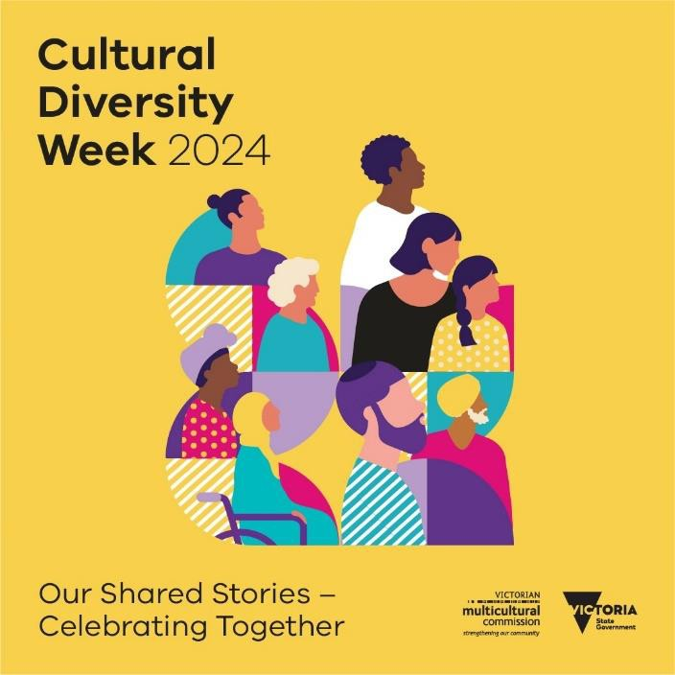
Instagram




Join us for Cultural Diversity Week from March 18-24!  This year's theme, "Our Shared Stories - Celebrating Together," invites you to share your unique experiences and connect with the diverse tapestry of our community.  - Share your stories: Whether it's a childhood memory or a journey across continents, every story adds to our rich tapestry.  - Raise awareness: Let's stand together against racial discrimination on UN International Day for the Elimination of Racial Discrimination on March 21.  - Get involved: Host an event, share your story online, or explore resources! ➡️ https://www.multiculturalcommission.vic.gov.au/event-resources  Let's make this Cultural Diversity Week unforgettable!  #CulturalDiversityWeek #OurSharedStories #CDW2024 @multiculturevic  Tag your friends and tell them why you celebrate diversity! | Dropbox link
LinkedIn
Join us for Cultural Diversity Week from March 18-24!  This year's theme, "Our Shared Stories - Celebrating Together," invites you to share your unique experiences and connect with the diverse tapestry of our community.  - Share your stories: Whether it's a childhood memory or a journey across continents, every story adds to our rich tapestry.  - Raise awareness: Let's stand together against racial discrimination on UN International Day for the Elimination of Racial Discrimination on March 21.  - Get involved: Host an event, share your story online, or explore resources! ➡️ https://www.multiculturalcommission.vic.gov.au/event-resources  Let's make this Cultural Diversity Week unforgettable!  #CulturalDiversityWeek #OurSharedStories #CDW2024 @multiculturevic  Tag your friends and tell them why you celebrate diversity! | Dropbox link  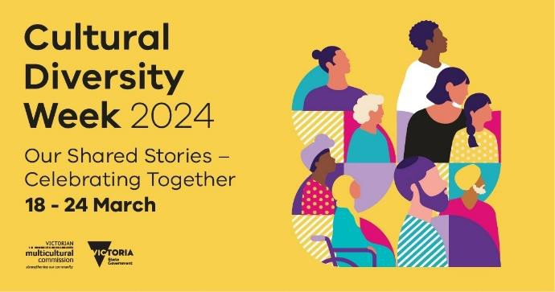

e-news letter
Title: Celebrate Cultural Diversity Week  Join us in celebrating Cultural Diversity Week from 18th to 24 March! This year, the Victorian Multicultural Commission invites you to embrace the beauty of diversity through the power of #OurSharedStories.  From cherished memories to journeys across continents, every story contributes to the rich tapestry of our multicultural identity. Share your story and explore others' narratives here - https://bit.ly/3uFMJFa  The Week also reminds all of the UN’s International Day for the Elimination of Racial Discrimination on 21st March. Whilst important to acknowledge and celebrate our cultural diversity, it’s also important to better understand and address the flight of racial discrimination and racism.  Whether you're an individual, part of a community group, a business, or a government agency, we encourage you to host your own Cultural Diversity Week event or activity.  Join the statewide conversation by using hashtags #CulturalDiversityWeek, #Oursharedstories, #CDW2024 and tag us on socials @multiculturevic  Explore resources, find inspiration, and discover more by visiting https://www.multiculturalcommission.vic.gov.au/eve nt-resources  Let's make this celebration unforgettable! | Dropbox link

