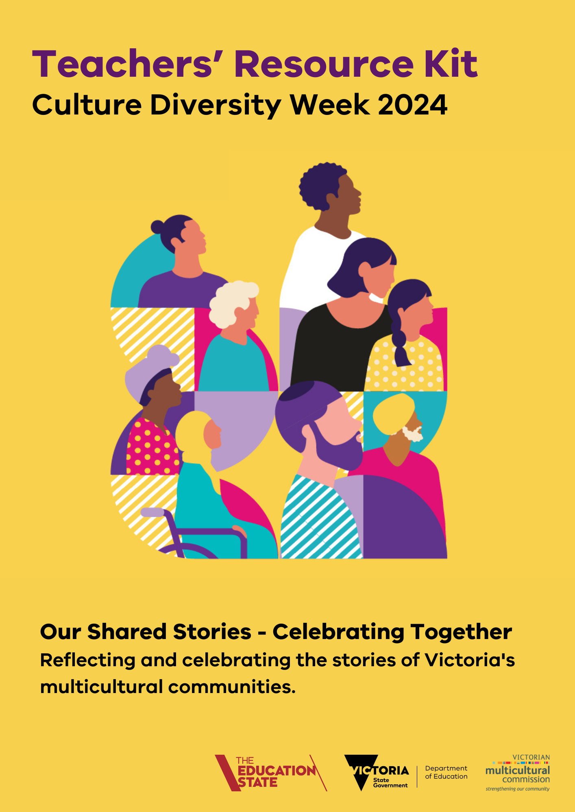

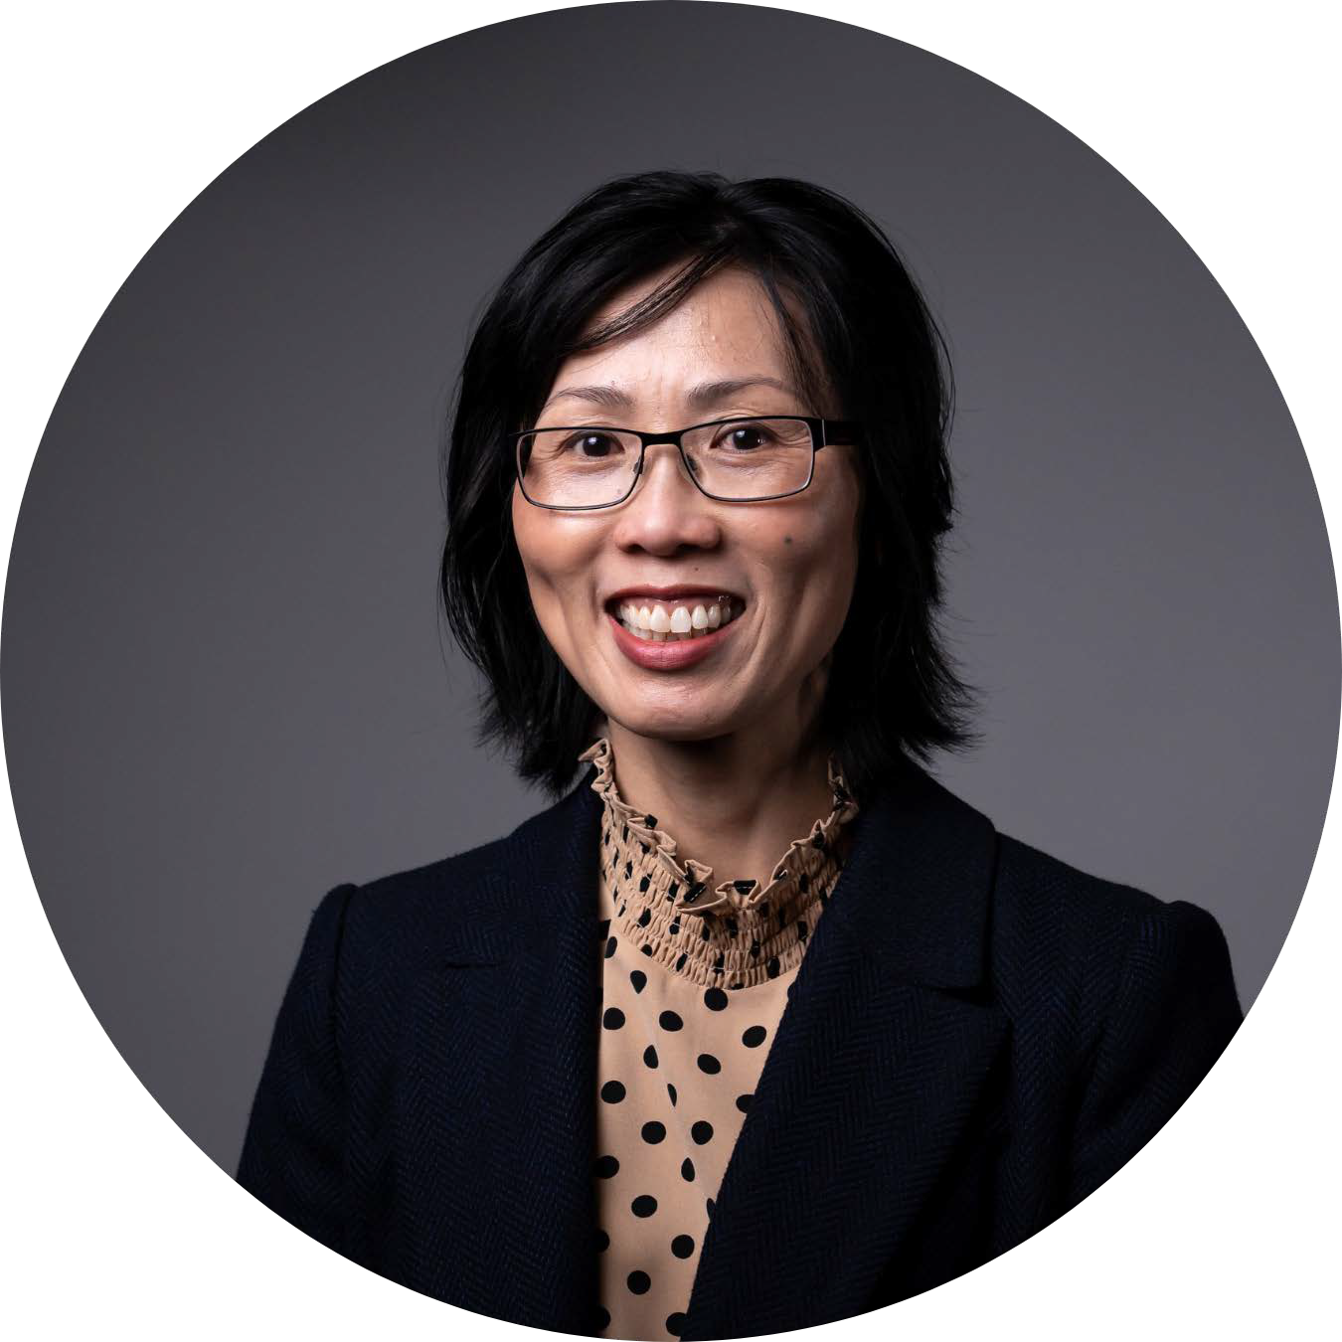**Message from the VMC Chairperson**

As we approach March, I am excited to announce the upcoming Cultural Diversity Week, Victoria's recognition of our rich multicultural heritage. From March 18 to 24, our state will honour the diverse cultures and stories that make Victoria truly unique.

## This year, our theme is "Our Shared Stories - Celebrating Together," inviting each of us to contribute to the vibrant tapestry of experiences that define our multicultural identity.

In a state where 290 languages are spoken and 314 different ancestries are represented, our diversity is not just a statistic but a testament to the richness of our collective history and heritage.

During Cultural Diversity Week, I invite you to raise your voices, open your hearts, and share your stories. Whether you whisper a personal moment or sing out your entire saga, there's a place for your voice in this symphony of shared experiences.

Teachers are respected in our society and your role is especially important in Cultural Diversity Week. I have seen how excited my children have been for a number of years during this week when they get to be involved in drawing, storytelling, food sharing and many other wonderful activities. Teachers help young people develop the ideas and perspectives that will determine how they shape the world of tomorrow and the future of Victoria is undeniably multicultural.

That is why I am very excited to present the VMC’s 2024 Cultural Diversity Week Teachers’ Resource Kit, developed in collaboration with the Department of Education. I thank their staff for their time, contributions and for helping us share this Kit among teachers.

Let's come together as Victorians to celebrate the humanity that binds us through shared stories. Join us in honouring our past, embracing our present, and envisioning our future as a diverse and inclusive community.

Thank you for your continued support and participation in Cultural Diversity Week. Together, let us make this year's celebration a memorable and meaningful experience for all.

Warm regards,

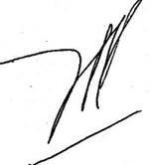

## Vivienne Nguyen

Chairperson

Victorian Multicultural Commission

# Acknowledgement of Country

The VMC acknowledges Aboriginal and Torres Strait Islander people as the Traditional Custodians of the land and acknowledges and pays respect to their Elders, past and present.

# About Cultural Diversity Week

Victoria’s annual Cultural Diversity Week (CDW) is led by the Victorian Multicultural Commission to celebrate cultural diversity and is centred on the United Nation’s (UN) Day for the Elimination of Racial Discrimination. It’s a great opportunity to highlight and celebrate the cultures within and around your school by hosting events or focusing the week’s activities on intercultural capability.

CDW focuses on Victorians with a migrant, refugee or asylum seeker background. First Nations People are an important part of cultural diversity and are Australia’s - and the world’s - oldest culture. Celebrations and acknowledgements of Aboriginal and Torres Strait Islander culture should be run throughout the year, particularly in NAIDOC Week and can be part of school’s CDW activities.

We recognise the Australian Government’s [Harmony Week](https://www.harmony.gov.au/) from 20 to 26 March 2024, which has had a particular focus on schools, and the Scanlon Foundation’s [Taste of Harmony](https://www.tasteofharmony.org.au/) from 18 to 19 March 2024, which focuses on workplaces. CDW encourages participation from school, workplaces and community groups, places of worship, businesses, and State and local government.

As a Victorian initiative, we encourage Victorian schools to participate in CDW and use this Kit’s Victorian-specific resources, in addition to the valuable resources available through the Harmony Week and Taste of Harmony campaigns, both referenced in this Kit.

The 2024 dates for CDW were chosen to include the UN Day for the Elimination of Racial Discrimination on 21 March while allowing for the strongest participation among Muslim Victorians, who expect to observe Ramadan from around 10 March.

# 2024 Cultural Diversity Week

## The 2024 CDW theme is Our Shared Stories - Celebrating Together: Reflecting and celebrating the stories of Victoria's multicultural communities.

This theme invites us to embark on a journey of collective reflection and vibrant celebration. It's a chance to weave together the threads of our rich multicultural tapestry, honouring the stories of established and emerging communities alike.

Victoria’s future is undeniably and proudly multicultural and has been for many years. This includes the diversity and longevity of Aboriginal culture, which can always be incorporated.

The theme will be used by organisations and businesses to guide their CDW events and celebrations. We encourage teachers to do the same, and to thread this theme throughout discussions and activities.

2024 branded digital resources are available on the VMC’s [Cultural Diversity Week 2024 website](https://www.multiculturalcommission.vic.gov.au/cultural-diversity-week-victorian-multicultural-commission). These include:

* [an email signature banner and social media tiles](https://www.multiculturalcommission.vic.gov.au/event-resources)
* [PowerPoint template](https://www.multiculturalcommission.vic.gov.au/event-resources)
* [MS word template](https://www.multiculturalcommission.vic.gov.au/event-resources)

# About the Victorian Multicultural Commission (VMC)

The Victorian Multicultural Commission was established as a statutory body in 1983 and is constituted under the Multicultural Victoria Act 2011. Last year, we celebrated our 40-year anniversary.

## We strengthen our community through support, celebrations and advocacy for culturally and linguistically diverse Victorians.

The VMC is dedicated to

* promoting cultural diversity across all areas of society
* advocating on behalf of multicultural communities to all levels of government
* full participation by all Victorians regardless of their cultural, linguistic and religious backgrounds.

Acting as a vital conduit between the state’s culturally, religiously and linguistically diverse communities and the Victorian Government, the VMC fosters social cohesion in Victoria and promotes cultural diversity through a strengths-based approach and by empowering community-based solutions.

We connect multicultural communities with government (and government with community)

by engaging directly with people to understand issues. We work together to identify and recommend potential solutions to government, policy makers and community organisations to make public services more inclusive and accessible for culturally diverse Victorians.

Learn more about us by reading our [2022 – 2023 Annual Report](https://www.multiculturalcommission.vic.gov.au/victorian-multicultural-commission-annual-reports)

# About the Teacher’s Resource Kit

Victoria is known for its multiculturalism. Victorians come from more than 300 different ancestries and collectively, we speak 290 languages. Cultural, linguistic and faith-based diversity is one of our greatest assets.

## Schools play a critical role in strengthening cultural inclusion in our community. They provide an environment where acceptance of diversity, knowledge of other cultures and understanding of global and local issues are developed and are part of everyday life.

By providing safe, inclusive and welcoming classrooms, teachers help students feel a sense of belonging and connection to their school, community and to Victoria.

There are many ways teachers and schools can help foster community harmony and encourage positive attitudes towards cultural diversity.

This Kit is designed to provide inspiration and assistance to help your school acknowledge and celebrate cultural diversity in the classroom. We’ve included links to curriculum resources, ideas for classroom discussion and other activities to undertake during CDW.

This Kit is available online at VMC’s [2024 Cultural Diversity Week website](https://www.multiculturalcommission.vic.gov.au/cultural-diversity-week-victorian-multicultural-commission)

# 2024 Ideas for Schools

## The 2024 theme is “Our Shared Stories - Celebrating Together: Reflecting and celebrating the stories of Victoria's multicultural communities.”

**Schools are invited to reflect on the many cultures and communities that have shaped Victoria in the past and to look to the future of Victoria as a multicultural state.**

The following prompts can be linked to [Victorian Curriculum: F-10 Intercultural Capability](https://victoriancurriculum.vcaa.vic.edu.au/intercultural-capability/introduction/rationale-and-aims) and to ‘Civics and Citizenship’ under the [Citizenship, Diversity and Identity](https://victoriancurriculum.vcaa.vic.edu.au/the-humanities/civics-and-citizenship/introduction/rationale-and-aims) learning and teaching stream.

The curriculum can be used to create discussion plans suited to primary or secondary settings.

The [VCAA website](https://www.vcaa.vic.edu.au/curriculum/foundation-10/resources/intercultural-capability/Pages/default.aspx) includes some existing curriculum resources to assist, as does the [Student](https://www.education.vic.gov.au/Documents/school/teachers/teachingresources/multicultural/Student_Leaders_for_Multicultural_Inclusion.pdf) [Leaders for Multicultural Inclusion (SLMI) resource](https://www.education.vic.gov.au/Documents/school/teachers/teachingresources/multicultural/Student_Leaders_for_Multicultural_Inclusion.pdf). [Schools Standing Up to Racism](https://www.cmy.net.au/schools-standing-up-to-racism/) is another useful resource for Victorian schools developed by the Centre for Multicultural Youth.

Schools might want to invite their [Multicultural Education Aides](https://www.education.vic.gov.au/PAL/eal-mea-handbook.pdf) (MEAs) to participate in planning class activities and discussions.

|  |  |
| --- | --- |
| **Topic** | **Description** |
| **Discussions** | |
| **Multiculturalism** | Facilitate a discussion with students on multiculturalism, belonging, differences and similarities.  Potential questions:   * What is culture? Cultural identity? Ethnicity? * What is a story from your culture that is significant to you? * What stories and traditions did you grow up with? * What values did those stories teach you? * What are our differences? What similarities do we share? * What are some ways we feel different and how can we celebrate these differences in our community? * Why is it important to feel like you belong? * What might make someone feel like they don’t belong? * What can we do to help a person feel like they belong?   You could also run a game of bingo including a few multicultural facts. Students can mark their cards if they can relate to the fact, or to find others in the room who match the description in the box. An example is [available here.](https://bingobaker.com/view/4894156) |

|  |  |
| --- | --- |
| **Topic** | **Description** |
| **Difference** | Challenge students to think and reflect about when they have felt different in the past.  This can be done as a class or in pairs who can talk about one way they feel different, special or unique. Maybe they speak another language, their family enjoys a particular type of food or they celebrate a certain tradition.   * As a class, discuss the benefits of having different kinds of people in a class and find out what values you share with the other person. * What would be the disadvantages if everyone in the class were the same? * Why do you think difference is important?   Ask students to identify similarities and differences where two or more students share a cultural heritage. This activity could also be done with two more students with a different cultural heritage. |
| **Traditions** | Encourage students to identify and share how their cultural heritage and identity is expressed. For example, in celebrating birthdays, holidays or other important times, special foods, music or prayers.  Students could also demonstrate traditional dance, songs, or crafts.  Parents/guardians and grandparents could also be included in this exercise. |
| **Acknowledge First Nations People** | While CDW focuses on those with a migrant, refugee or asylum seeker background, it can also be a time to discuss First Nations people, and why it’s important for all Australians to respect and seek to understand First Nations people.  Classes could also discuss the difference between Welcome to Country and Acknowledgment of Country and why we do it.  [This map](https://aiatsis.gov.au/explore/map-indigenous-australia) of Traditional Owners with land divisions and language groups could be shown as part of a classroom activity to show how multicultural Australia has always been. |
| **Names** | Ask students to share the origin of their name, along with any traditions around names. They can ask their families for information or do research online in the classroom. You could explore what the names mean and ask students to share this with the class.  Research could also include mapping family trees or marking students’ family origins on a map of the world. |
| **Arriving as a migrant, refugees or asylum seeker** | Lead an age-appropriate discussion on the difference between arriving as a migrant, refugee or asylum seeker.  This should include noting that how a person arrives in a country does not define who they are now, or in the future. This could lead into a discussion about the use of language and why that matters. For example, while a person may have arrived as a refugee, they may now be an Australian citizen, so it’s best to say ‘people who arrived as a migrant / refugee / asylum seeker’. |

|  |  |
| --- | --- |
| **Topic** | **Description** |
|  | The Centre for Multicultural Youth has videos and audio clips of [in-depth](https://www.cmy.net.au/schools-standing-up-to-racism/shared-understanding/) [interviews](https://www.cmy.net.au/schools-standing-up-to-racism/shared-understanding/) with young students for classroom screenings. |
| **Racism** | Lead age-appropriate discussions about the impact of racism on mental and physical health, racism as a barrier to civic participation and employment, racism can be addressed, and why the origin of CDW as the UN Day for the Elimination of Racial Discrimination remains important.  It may not be appropriate to seek student’s personal experiences, but to use case studies or videos to illustrate the impacts of racism.  This may raise negative memories for students with lived-experience of racism, so should be done with the provision of tools and resources to manage those feelings, and ideally with a trained facilitator.  CDW could be a good time to organise anti-racism education for students, SRC reps or staff. This could also take the form of training and education on being an active bystander when witnessing racism, being a good ally or on identifying and addressing unconscious bias. Some useful resources are available through:   * [Courage to Care,](https://couragetocare.org.au/upstander-programs/) which offers free student workshops that promote acceptance of diversity, transform bystander behaviour and inspire participants to become Upstanders in their own communities. * [Victorian Equal Opportunity & Human Rights Commission’s](https://www.humanrights.vic.gov.au/education/reducing-racism-hub/about/) [Reducing Racism Hub.](https://www.humanrights.vic.gov.au/education/reducing-racism-hub/about/) * [Racism No Way](https://racismnoway.com.au/) was developed by the NSW Department of Education on behalf of all Australian schools and has many age- specific teaching resources. * Racism. [It Stops With Me](https://itstopswithme.humanrights.gov.au/about-the-campaign) is a national anti-racism campaign led by the Australian Human Rights Commission. * [All Together now](https://alltogethernow.org.au/about-us/who-we-are/) is an independent, secular, non-partisan, not- for-profit organisation that offers training to support young people vulnerable to being targeted by far-right extremists. |
| **Self-care for students and teachers.** | * The Centre for Multicultural Youth has developed resources for school leaders and teachers, including those who are facilitating conversations about racism within the school environment:   + [Facilitating Conversations About Racism – A guide for teachers](http://cmy.wpenginepowered.com/wp-content/uploads/2023/09/Facilitating-Conversations-about-Racism-A-Guide-for-teachers-and-school-leaders.pdf) [and school leaders](http://cmy.wpenginepowered.com/wp-content/uploads/2023/09/Facilitating-Conversations-about-Racism-A-Guide-for-teachers-and-school-leaders.pdf)   + [Facilitating Conversations About Racism – Navigating common](http://cmy.wpenginepowered.com/wp-content/uploads/2023/09/Facilitating-Conversations-about-Racism-Navigating-Common-Challenges.pdf) [challenges](http://cmy.wpenginepowered.com/wp-content/uploads/2023/09/Facilitating-Conversations-about-Racism-Navigating-Common-Challenges.pdf)   + [Short guide to assisting parents, families and carers on racial](http://cmy.wpenginepowered.com/wp-content/uploads/2020/06/Racial-Discrimination-in-the-Community.pdf) [discrimination in the community](http://cmy.wpenginepowered.com/wp-content/uploads/2020/06/Racial-Discrimination-in-the-Community.pdf) |
| **The wider community** | |

|  |  |
| --- | --- |
| **Topic** | **Description** |
| **Invite a VMC Commissioner or other speaker to your school** | Invite a [VMC Commissioner](https://www.multiculturalcommission.vic.gov.au/our-commissioners)1, local author, community leader or historian from Victoria’s multicultural community to speak or present at your school. Some parents or 'family members may also be willing to speak and/or share some music, art or even food.  Suggested speaker topics:   * the importance of cultural diversity to Victoria’s past, present and future * how cultural diversity has evolved throughout Victoria’s history * the challenges and benefits of living and working in a culturally diverse state, country or world * explore the speaker’s own cultural identity and the story of how they came to live in Australia or how their parents, grandparents or great- great grandparents came to Australia. |
| **Local businesses** | Students could interview local business owners with a multicultural background, and report back to the class. For example, asking them how they got started, where they learnt their skills, about the items they sell and even how they create an inclusive environment for employees and customers. |
| **Face-to-face program** | [The Face-to-Face program](https://www.refugeecouncil.org.au/f2f-overview/) involves a speaker with a refugee background and a representative of the Refugee Council of Australia co- presenting to your school.  Presentations are tailored for primary and secondary students and teachers – topics include:   * who refugees are and where they come from * facts about refugees worldwide and in Australia * the conditions refugees face overseas * Australia’s refugee policies |
| **Activities** | |
| **SBS Census Tracker** | Ask students to guess how culturally diverse their area or suburb is compared to different parts of Victoria and Australia. They can use the [SBS Census Tracker,](https://www.sbs.com.au/news/creative/census-explorer/xtjxeqygs) which includes statistics from the 2021 Census.  List the names of students in order of the highest cultural diversity of the suburb in which they live.  Students can also guess which culture is the most represented in the school’s suburb, perhaps comparing it with the suburb that was most culturally diverse when their parents were at school. |
| **Research project** | Ask students to investigate and even present their research on:   * the history of multiculturalism in Victoria or Australia * the history and stories of migration from overseas * stories of business owners with a multicultural background * stories of people with refugee, asylum seeker or migrant backgrounds, and their settlement in, and contribution to Victoria |

1 Please contact [commissioners@vmc.vic.gov.au](mailto:commissioners@vmc.vic.gov.au) to request a VMC Commissioner to attend your school.

|  |  |
| --- | --- |
| **Topic** | **Description** |
|  | * the comparison between multiculturalism in Australia and other countries, such as Canada, New Zealand, Japan or Germany * their family’s arrival in Australia, perhaps using information found in the [National Archives of Australia.](https://www.naa.gov.au/explore-collection/immigration-and-citizenship/passenger-arrival-records) |
| **Show and share** | Ask students to bring in an item or photo from home that has special cultural significance or heritage. They can share the story of the item, explaining why it is important to their family or culture.  Photos could be displayed in an exhibition on a classroom wall. |
| **Watch a film** | Watch age-appropriate Official Selection films from the 2023 and previous Multicultural Film Festivals on the [VMC’s YouTube channel,](https://www.youtube.com/watch?v=OtuQM2Byz98&list=PLKMWHU5SuOmkwSDb9KuTXB4VFi3ZTc8YE) including those made by school students. |
| **Library exhibition** | Display a range of culturally diverse picture books, chapter books and novels in the school library or classroom. For example, one for middle secondary students is ‘*F Team’* by Rawah Arja. Many more can be found at [NCACL Cultural Diversity Database - NCACL](https://www.ncacl.org.au/ncacl-cultural-diversity-database/) |
| **Read a book** | Read a book to younger students on traditions around the world. Some suggestions are:   * ‘*Throw your tooth on the roof: tooth traditions from around the world’* by Selby Beeler (available through the [Languages and](https://lmerc.softlinkhosting.com.au/oliver/home/resources/details/e8639e96c0a8146c01db7e0b76f22e0b) [Multicultural Education Resource Centre (LMERC)](https://lmerc.softlinkhosting.com.au/oliver/home/resources/details/e8639e96c0a8146c01db7e0b76f22e0b)) * *‘My name is not* Refugee’ by Kate Milner, available through [Barrington Stoke](https://www.barringtonstoke.co.uk/wp-content/uploads/2019/05/mninr_teachers_LOW.pdf) * Several options on pages *26-28 of the* [*Refugee Council of*](https://www.refugeeweek.org.au/wp-content/uploads/2021/02/RCOA-Teachers-Resource-Kit-Refugee-Week-2022-WEB-1.pdf)[*Australia’s 2022 Refugee Week Teacher’s Resource Kit*](https://www.refugeeweek.org.au/wp-content/uploads/2021/02/RCOA-Teachers-Resource-Kit-Refugee-Week-2022-WEB-1.pdf)   Read a book authored by a culturally diverse person. For example, Nam Le, Anh Do, Natalie Kon-yu, Eunice Andrada.   * Alice Pung * Aunty Faye Muir * Aunty Joy Murphy * Maxine Beneba Clarke * Rebecca Lim, * Gabrielle Wang, * Huda Hayek, * Felice Arena, * Leanne Hall |

|  |  |
| --- | --- |
| **Topic** | **Description** |
| **Develop student leaders** | Use the [*Student Leaders for Multicultural Inclusion*](https://www.education.vic.gov.au/Documents/school/teachers/teachingresources/multicultural/Student_Leaders_for_Multicultural_Inclusion.docx)resource to empower students take the lead on identifying opportunities and implementing ideas to strengthen intercultural understanding and celebrate cultural diversity in your school. The [Multicultural education programs and](https://www.education.vic.gov.au/school/teachers/teachingresources/multicultural/Pages/multidepth.aspx) [resources](https://www.education.vic.gov.au/school/teachers/teachingresources/multicultural/Pages/multidepth.aspx) webpage has similar resources. |
| **Share a meal** | Organise a catered lunch sourced from social enterprises that support Victorians who arrived as a refugee or asylum seeker. For example:   * [Free to Feed](https://www.freetofeed.org.au/) * [Asylum Seeker Resource Centre](https://www.catering.asrc.org.au/) |
| **Excursions** | |
| **Immigration Museum** | Plan an excursion to Melbourne’s [Immigration Museum](https://museumsvictoria.com.au/immigrationmuseum/learning/school-visit-information/) or use their range of [school programs and resources.](https://museumsvictoria.com.au/immigrationmuseum/learning/school-programs-and-resources/) |
| **Multicultural Museums Victoria** | Plan an excursion to one of Victoria’s [Multicultural Museums,](https://mmv.org.au/) such as the   * Hellenic Museum * Museum of Chinese Australian History * Islamic Museum of Australia * Jewish Museum of Australia * CO.AS.IT Museo Italiano. |
| **Visit a community organisation** | See firsthand the work being done by a [local ethnic communities](https://eccv.org.au/) [council](https://eccv.org.au/) or [migrant/refugee resource](https://asrc.org.au/) centre. Alternatively, you could invite a speaker to your class. |
| **Harmony Week Activities** | The Federal government’s [Harmony Week](https://www.harmony.gov.au/about) website has a range of resources including Instaframes, certificates, infographics and a DIY ‘hand-tree’ activity. |
| **A Taste of Harmony** | For staff or students, this campaign from the Scanlon Foundation encourages people to bring in food that reflects their cultural origins to share with others. The [Taste of Harmony](https://www.tasteofharmony.org.au/get-involved/) website has a range of resources, including recipes that you could cook in the classroom. <https://www.tasteofharmony.org.au/> website has a range of resources, including recipes that you could cook in the classroom. |

Additional resources for teachers in Cultural Diversity Week

## Victorian Department of Education (DE)

* + [Multicultural Education Programs and Resources](https://www.education.vic.gov.au/school/teachers/teachingresources/multicultural/Pages/multidepth.aspx)
  + [Languages and Multicultural Education Resource Centre (LMERC)](https://www.education.vic.gov.au/school/teachers/teachingresources/multicultural/Pages/lmerc.aspx?Redirect=1): A specialised library providing resources and advice to support the fields of Languages, EAL, Multicultural Education and the cross-curriculum priority areas and capabilities. Their catalogue includes curated lists for culturally diverse text selection and to support the intercultural capability.
  + [Koorie Teaching Resources](https://www.education.vic.gov.au/school/teachers/teachingresources/multicultural/Pages/koorieresources.aspx)
  + [Indigenous cross cultural training resources](https://www.education.vic.gov.au/school/teachers/teachingresources/careers/resourcekit/Pages/indigenousresources.aspx)
  + [Annual Events – celebrating cultural diversity](https://www.schools.vic.gov.au/multicultural-education-programs-resources#annual-events-%E2%80%93-celebrating-cultural-diversity)
  + [ARC: Intercultural Capability resources](https://arc.educationapps.vic.gov.au/search?searchText=intercultural%20capability)
  + [Bully Stoppers: Racist Bullying](https://www.education.vic.gov.au/about/programs/bullystoppers/Pages/racistbullying.aspx)
  + [Poster- Speaking in home language is the best way to help your child succeed](https://www.education.vic.gov.au/Documents/school/teachers/teachingresources/discipline/languages/SpeakLangBest3.pdf)
  + [Student Leaders for Multicultural Inclusion](https://www.education.vic.gov.au/Documents/school/teachers/teachingresources/multicultural/Student_Leaders_for_Multicultural_Inclusion.pdf) a comprehensive resource with activities designed for Victorian schools based on the Framework for Improving Student Outcomes (FISO 2.0).

## Victorian Curriculum Assessment Authority (VCAA)

* + [Intercultural Capability - Introduction and Curriculum](https://victoriancurriculum.vcaa.vic.edu.au/intercultural-capability/introduction/rationale-and-aims)
  + [Intercultural Capabilities- Find a teaching resource](https://urldefense.proofpoint.com/v2/url?u=https-3A__www.vcaa.vic.edu.au_curriculum_foundation-2D10_resources_intercultural-2Dcapability_Pages_Help-2Dme-2Dfind-2Da-2Dteaching-2Dresource.aspx&d=DwMFAg&c=JnBkUqWXzx2bz-3a05d47Q&r=jtiQzcGpeGUIUF7gkcejY2DrLOPzXbldAZ2ofaP2cIQ&m=x6X244yopspTwtMmcTceooa5syJEmbUHvtfZQ4N5CIU&s=lbBwJ9MKo3W30x_5iH9L9yz2rnB_o2xLETNoAAolTls&e)
  + [Teacher Guide- Navigating intercultural issues in the classroom](https://urldefense.proofpoint.com/v2/url?u=https-3A__www.vcaa.vic.edu.au_Documents_viccurric_intcult_Teacher-2520Guide-2520Navigating-2520Intercultural-2520Issues.pdf&d=DwMFAg&c=JnBkUqWXzx2bz-3a05d47Q&r=jtiQzcGpeGUIUF7gkcejY2DrLOPzXbldAZ2ofaP2cIQ&m=x6X244yopspTwtMmcTceooa5syJEmbUHvtfZQ4N5CIU&s=VVBrpAabyb8e55dgJiETUYS2pPIcvLYIshSp1I9q73Y&e)
  + [Poster- How do we talk about culture in the classroom](https://urldefense.proofpoint.com/v2/url?u=https-3A__www.vcaa.vic.edu.au_Documents_viccurric_intcult_Poster-2520primary-2520A3-2520How-2520do-2520we-2520talk-2520about-2520culture.pdf&d=DwMFAg&c=JnBkUqWXzx2bz-3a05d47Q&r=jtiQzcGpeGUIUF7gkcejY2DrLOPzXbldAZ2ofaP2cIQ&m=x6X244yopspTwtMmcTceooa5syJEmbUHvtfZQ4N5CIU&s=DH4h8wacowQ_eSaomTV6q1SwQ9OGekKGCQbo_Z5YTek&e)
  + [Victorian Aboriginal Languages](https://vcaa.vic.edu.au/curriculum/foundation-10/resources/languages/victorian-aboriginal-languages/Pages/default.aspx)
  + [Civics and Citizenship – Student-led classroom resources](https://www.vcaa.vic.edu.au/curriculum/foundation-10/resources/civics-and-citizenship/Pages/Student-ledCivicsandCitizenshipResources.aspx)

## Centre for Multicultural Youth (CMY)

* + [Education Programs](https://urldefense.proofpoint.com/v2/url?u=https-3A__www.cmy.net.au_organisations-2Dbusinesses_education_&d=DwMFAg&c=JnBkUqWXzx2bz-3a05d47Q&r=jtiQzcGpeGUIUF7gkcejY2DrLOPzXbldAZ2ofaP2cIQ&m=x6X244yopspTwtMmcTceooa5syJEmbUHvtfZQ4N5CIU&s=5j08dhs3szuMkjMuQY8Q3g0ja3rV974Zo7qux92ddjY&e)
  + [Schools Standing up to Racism – link to videos and written resources](https://www.cmy.net.au/schools-standing-up-to-racism/)
  + ​

## Courage to Care

* + [Schools Program](https://urldefense.proofpoint.com/v2/url?u=https-3A__couragetocare.org.au_our-2Dprogram_schools-2Dprogram_&d=DwMFAg&c=JnBkUqWXzx2bz-3a05d47Q&r=jtiQzcGpeGUIUF7gkcejY2DrLOPzXbldAZ2ofaP2cIQ&m=x6X244yopspTwtMmcTceooa5syJEmbUHvtfZQ4N5CIU&s=tZcOLUVcqi5F7eek7Q9ftmUZrfTXBnGdqGRoRp3Vl80&e)

## Facts and resources about people seeking asylum and of refugee backgrounds in Australia

* [Australian Human Rights Commission](https://humanrights.gov.au/our-work/rights-and-freedoms/publications/asylum-seekers-and-refugees)
* [Australian Red Cross](https://www.redcross.org.au/act/help-refugees/refugee-facts/)
* [Words that work: Asylum Seeker Resource Centre (ASRC)](https://www.asrc.org.au/wp-content/uploads/2016/05/ASRC-Words-that-Work-4pp.pdf)
* Refugee Council 2023 Teachers Toolkit
* Foundation Houses
  + [Schools Program](https://urldefense.proofpoint.com/v2/url?u=https-3A__foundationhouse.org.au_specialised-2Dprograms_schools_&d=DwMFAg&c=JnBkUqWXzx2bz-3a05d47Q&r=jtiQzcGpeGUIUF7gkcejY2DrLOPzXbldAZ2ofaP2cIQ&m=x6X244yopspTwtMmcTceooa5syJEmbUHvtfZQ4N5CIU&s=5hlDGSNAczF8DgCTgGaMylMUf4TbFuguOokYmyN13wc&e)
  + [Schools In For Refugees](https://sifr.foundationhouse.org.au/)

## Other sources

* + [NCACL Cultural Diversity Database - NCACL](https://www.ncacl.org.au/ncacl-cultural-diversity-database/)
  + [Immigration Museum](https://museumsvictoria.com.au/immigrationmuseum/)
  + [Welcome | SBS Learn](https://www.sbs.com.au/learn/welcome-to-sbs-learn#%3A~%3Atext%3DOur%20most%20popular%20teacher%20resources%201%20NAIDOC%20Week%2Con%20NITV%20documentary%2C%20Occupation%3A%20Native)%20More%20items.)
  + [Composer](https://urldefense.proofpoint.com/v2/url?u=https-3A__www.composereducation.org_&d=DwMGaQ&c=JnBkUqWXzx2bz-3a05d47Q&r=EaifmNkAxmsfD09EL6H5SViuqKISJQHTgH8veR9cD5o&m=s240Ftb2y6fPIRnDAH6JQUgtKV5N2gf35DMTJ1Nm4-hojtwiDkaQkQA7cCOqXpS8&s=cILYu8M8WRy7xs0fLnL-YSaPpm6CBmXMoPoSkenM02E&e)
  + [Understanding impact of racism on child and youth](https://www.vichealth.vic.gov.au/news-publications/research-publications/racism-racial-discrimination-and-child-and-youth-health)
  + Wellsprings for women
  + [All together now](https://alltogethernow.org.au/)
  + [The school that tried to end racism](https://iview.abc.net.au/show/school-that-tried-to-end-racism)
  + [Democracy in colour](https://democracyincolour.org/)
  + [Reconciliation Victoria](http://www.reconciliationvic.org.au/)
  + [Australian GLBTIQ Multicultural Council](https://www.agmc.org.au/)
  + [Australian Multicultural Foundation](https://amf.net.au/)
  + [OMG I’m QTIPOC](https://www.withrespect.org.au/community/resources/item/53-omg-i-m-qtipoc)